CHILD WINDOW CONTROLS

Child window controls are a powerful mechanism for creating user interfaces in Windows applications. They allow you to encapsulate specific functionality with regard to its graphical appearance on the screen, its response to user input, and its method of notifying another window when an important input event has occurred.

Creating Child Window Controls

There are two main ways to create child window controls:

Manually: You can create child window controls manually by defining a window class and registering it with Windows using RegisterClass. You then create the child window based on that class using CreateWindow.

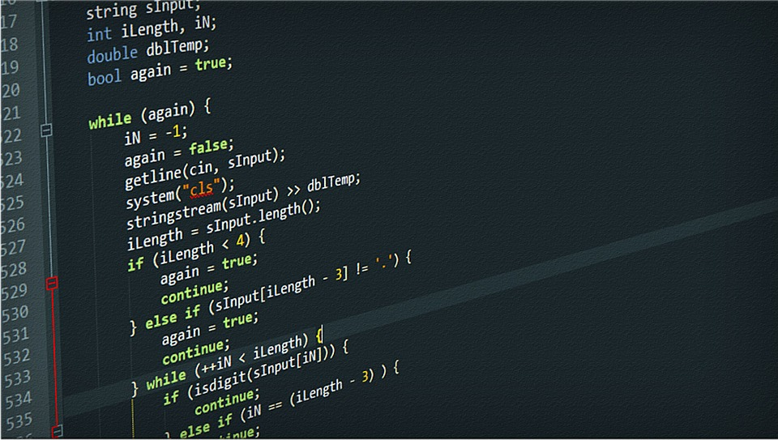

Using predefined controls: Windows provides a set of predefined child window controls that you can use without having to define your own window class. These controls include buttons, check boxes, edit boxes, list boxes, combo boxes, text strings, and scroll bars. To create a predefined child window control, you simply use the name of the control as the window class parameter in CreateWindow.



Communication between Child Window Controls and Parent Windows

Child window controls communicate with their parent windows using messages. The child window control sends messages to the parent window to notify it of important events, such as a button being clicked or a value being changed in an edit box. The parent window sends messages to the child window control to set its properties, such as its text or its enabled state.



Child Window Controls in Dialog Boxes

Child window controls are used extensively in dialog boxes. The dialog box manager handles the placement and sizing of the child window controls, and it also provides a layer of insulation between your program and the controls themselves. This makes it easier to create dialog boxes without having to worry about the low-level details of child window controls.

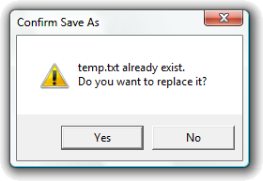

Child Window Controls on Normal Windows

You can also use child window controls on the surface of a normal window's client area. However, this involves more work than using child window controls in dialog boxes, because you have to handle the placement and sizing of the child window controls yourself. You also have to handle the input focus, which can be a challenge.

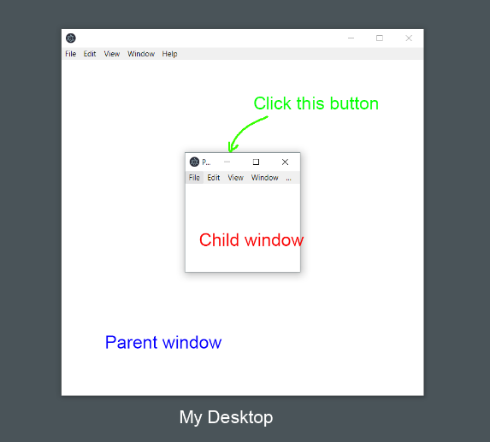

Common Controls

Windows provides a set of specialized child window controls that are collectively known as "common controls." These controls are more complex than the simple standard controls, and they provide additional functionality, such as the ability to display images and to handle drag-and-drop operations.

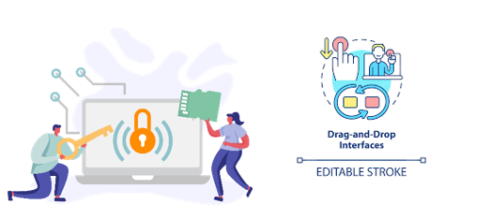

Additional Notes

The Windows programming documentation discusses child window controls in two places:

* Simple standard controls: These controls are described in /Platform SDK/User Interface Services/Controls.
* Common controls: These controls are described in /Platform SDK/User Interface Services/Shell and Common Controls/Common Controls.

I won't be discussing the common controls in this chapter, but they'll appear in various programs throughout the rest of the book.

*BtnLook program in chapter 9…*

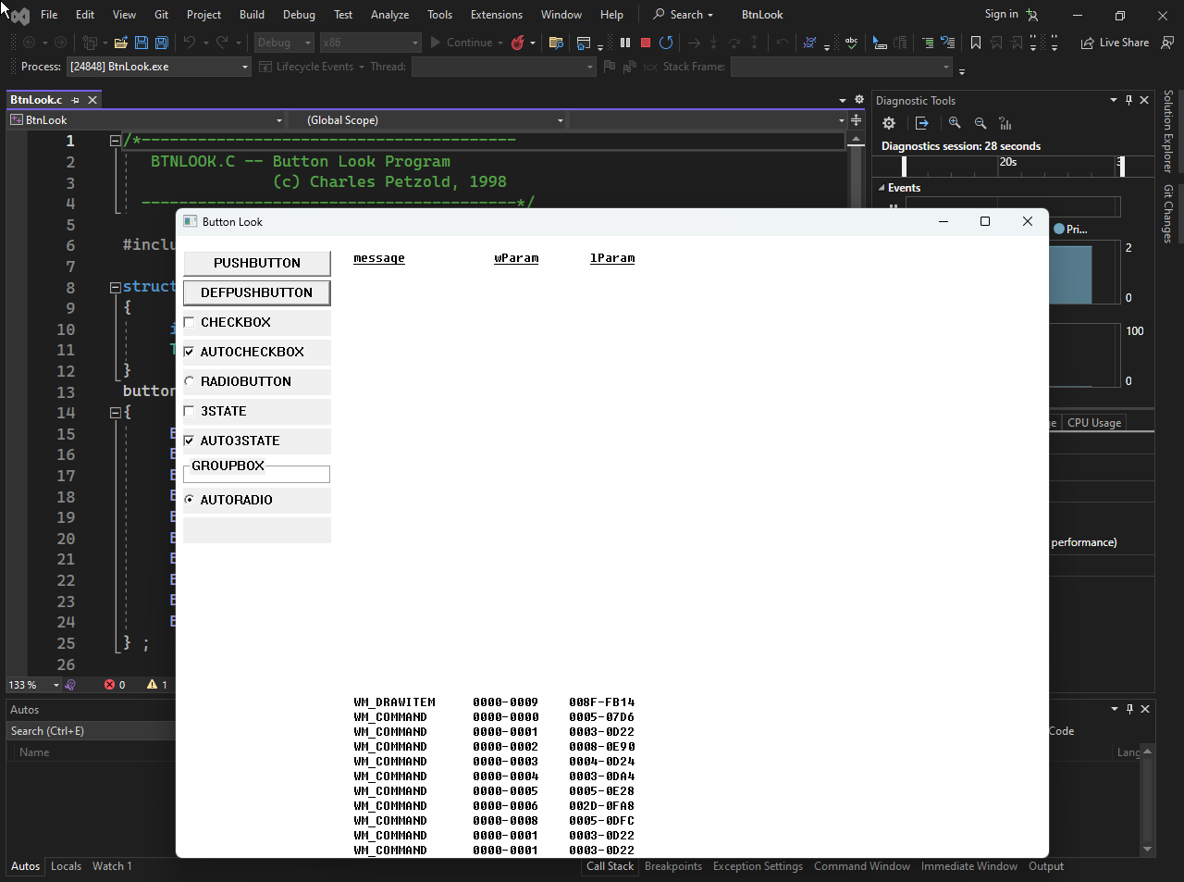

The video illustration…



BTNLOOK Program Overview

The BTNLOOK program creates 10 child window button controls, one for each of the 10 standard styles of buttons. It displays the wParam and lParam parameters of the WM_COMMAND messages sent by the buttons to the parent window procedure. The button with the style BS_OWNERDRAW is displayed with a background shading because this is a style of button that the program is responsible for drawing.

Key Functionalities

Creates 10 child window button controls using the CreateWindow function.

* Handles WM_CREATE, WM_SIZE, WM_PAINT, WM_DRAWITEM, WM_COMMAND, and WM_DESTROY messages.
* Displays the wParam and lParam parameters of the WM_COMMAND messages sent by the buttons.
* Handles owner-draw buttons, which are buttons that the program is responsible for drawing.
* The WndProc function handles all of the window messages for the main window.
* The CreateWindow function is used to create the child window button controls.
* The WM_CREATE message handler creates the child window button controls and sets their initial positions.
* The WM_SIZE message handler updates the positions of the child window button controls when the window is resized.
* The WM_PAINT message handler draws the background of the window and the text labels for the buttons.
* The WM_DRAWITEM message handler is sent to the owner-draw button, and it is responsible for drawing the button.
* The WM_COMMAND message handler is sent to the parent window procedure whenever a button is clicked.
* The WM_DESTROY message handler cleans up the resources used by the program and posts a WM_QUIT message to the message queue.

Additional Notes:

* The program uses the GetDialogBaseUnits function to get the character size for the system font.
* The program uses the ScrollWindow function to scroll the contents of the client area when the buttons are resized.
* The program uses the InvalidateRect function to invalidate the client area when the buttons are clicked.

Child Windows

Child windows are windows that are created within the client area of another window, called the parent window. Child windows are typically created to provide additional functionality or content to the parent window. For example, a button on a dialog box is a child window of the dialog box.

Creating Child Windows

Child windows are created using the CreateWindow function. The CreateWindow function takes a number of parameters, including the following:

* Class name: The name of the window class. The window class defines the default appearance and behavior of the window.
* Window text: The text that will be displayed in the window's title bar.
* Window style: A set of flags that determine the appearance and behavior of the window.
* x position: The x-coordinate of the upper-left corner of the window's client area relative to the upper-left corner of the parent window's client area.
* y position: The y-coordinate of the upper-left corner of the window's client area relative to the upper-left corner of the parent window's client area.
* Width: The width of the window's client area.
* Height: The height of the window's client area.
* Parent window: The handle to the parent window.
* Child window ID: An ID that identifies the child window.
* Instance handle: The instance handle of the application.
* Extra parameters: Additional parameters that can be specified for certain types of windows.

Creating Buttons

Buttons are a common type of child window. To create a button, you can use the CreateWindow function and specify the following parameters:

* Class name: TEXT("button")
* Window text: The text that will be displayed on the button.
* Window style: WS_CHILD | WS_VISIBLE | BS_DEFPUSHBUTTON
* x position: The x-coordinate of the upper-left corner of the button relative to the upper-left corner of the parent window's client area.
* y position: The y-coordinate of the upper-left corner of the button relative to the upper-left corner of the parent window's client area.
* Width: The width of the button.
* Height: The height of the button.
* Parent window: The handle to the parent window.
* Child window ID: The ID of the button.
* Instance handle: The instance handle of the application.
* Extra parameters: NULL

Processing Child Window Messages

Child windows send messages to their parent window to communicate with it. The parent window is responsible for processing these messages. To process child window messages, the parent window's window procedure must handle the WM_COMMAND message.

Destroying Child Windows

Child windows are destroyed when their parent window is destroyed. You can also destroy a child window explicitly using the DestroyWindow function.

Additional Notes

* Child windows can be nested. This means that a child window can be the parent of other child windows.
* Child windows can be modal or non-modal. Modal child windows prevent the user from interacting with other windows until the modal child window is closed.
* Child windows can be repainted by the parent window or by the system.

The code that creates the child windows is located in the WndProc function.

Specifically, the code is located in the WM_CREATE message handling block. The code creates 10 child windows, one for each of the 10 button styles. The code uses the CreateWindowEx function to create the child windows. The CreateWindowEx function takes the following parameters:

* hParent: The handle to the parent window.
* hInstance: The instance handle of the application.
* lpClassName: The name of the window class.
* lpWindowName: The text that will be displayed in the window's title bar.
* dwStyle: A set of flags that determine the appearance and behavior of the window.
* x: The x-coordinate of the upper-left corner of the window's client area relative to the upper-left corner of the parent window's client area.
* y: The y-coordinate of the upper-left corner of the window's client area relative to the upper-left corner of the parent window's client area.
* cx: The width of the window's client area.
* cy: The height of the window's client area.
* hMenu: The handle to the window's menu.
* lpCreateStruct: A pointer to a CREATESTRUCT structure.
* lpvParam: An optional pointer to extra parameters.

The code that creates the child windows is as follows:

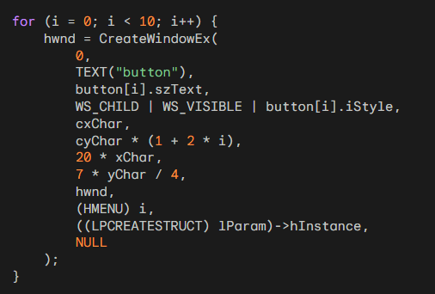

This code creates a child window for each of the 10 button styles. The code uses the following parameters:

* lpClassName: The name of the window class is TEXT("button").
* lpWindowName: The text that will be displayed in the window's title bar is:

button[i].szText.

* dwStyle: The window style is WS_CHILD | WS_VISIBLE | button[i].iStyle.
* x: The x-coordinate of the upper-left corner of the window's client area is cxChar.
* y: The y-coordinate of the upper-left corner of the window's client area which is:

cyChar * (1 + 2 * i).

* cx: The width of the window's client area is 20 * xChar.
* cy: The height of the window's client area is 7 * yChar / 4.
* hParent: The handle to the parent window is hwnd.
* hMenu: The child window ID is (HMENU) i.
* lpCreateStruct: The instance handle of the application is:

((LPCREATESTRUCT) lParam)->hInstance.

The code creates the child windows in a for loop. The loop iterates over the 10 button styles. For each button style, the code creates a child window and then increments the i counter.

Here is an explanation of how to get the instance handle for a window procedure using a global variable named hInst. Create a global variable:



Set the global variable in WinMain:



Use the global variable in the window procedure:

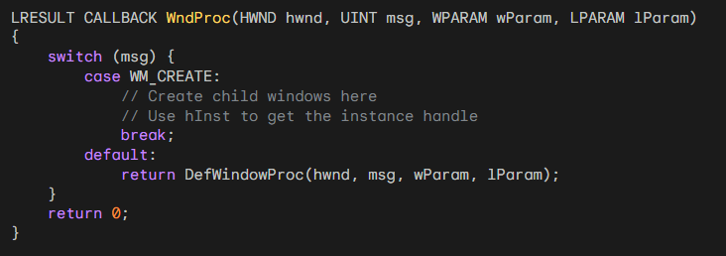

Use the instance handle to create child windows:

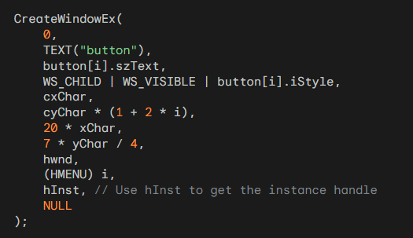

Get the instance handle using GetWindowLong:



This code will get the instance handle for the window procedure and store it in the global variable hInst. The instance handle can then be used to create child windows and perform other tasks that require the instance handle.

WHEN A BUTTON IS CLICKED

When a button is clicked, the child window control sends a WM_COMMAND message to its parent window. The WM_COMMAND message is a notification message that is sent by a control window to its parent window to indicate that the control has been activated.

The WM_COMMAND message has three parameters:

* wParam: The low-order word of wParam contains the child window ID. The high-order word of wParam contains the notification code.
* lParam: The lParam parameter contains the handle of the child window.

Child window ID

The child window ID is the value that is passed to the CreateWindow function when the child window is created. In BTNLOOK, the child window IDs are 0 through 9 for the 10 buttons that are displayed in the client area.

Notification code

The notification code indicates in more detail what the WM_COMMAND message means. The possible values of button notification codes are defined in the Windows header files. The following table shows the notification codes that are used by BTNLOOK:

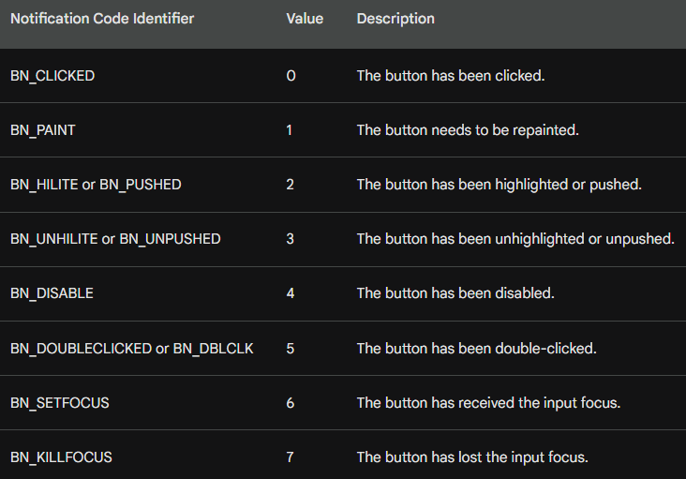

Handling WM_COMMAND messages

The parent window of the child window control is responsible for handling WM_COMMAND messages. BTNLOOK handles WM_COMMAND messages by trapping the message in the WndProc function. The WndProc function then extracts the child window ID and notification code from the wParam parameter and the child window handle from the lParam parameter. The WndProc function then uses these values to display the values of wParam and lParam.

Input focus

When you click a button with the mouse, the button receives the input focus. This means that all keyboard input is now sent to the child window button control rather than to the main window. However, when the button control has the input focus, it ignores all keystrokes except the Spacebar, which now has the same effect as a mouse click.

The following code shows how BTNLOOK handles WM_COMMAND messages:

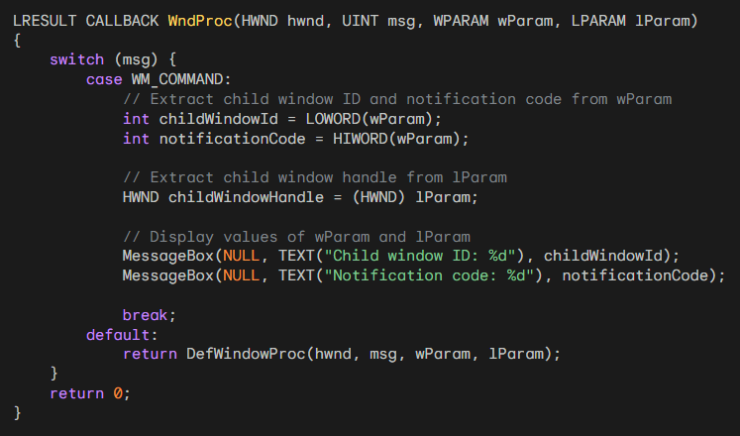

Let’s correct this code…

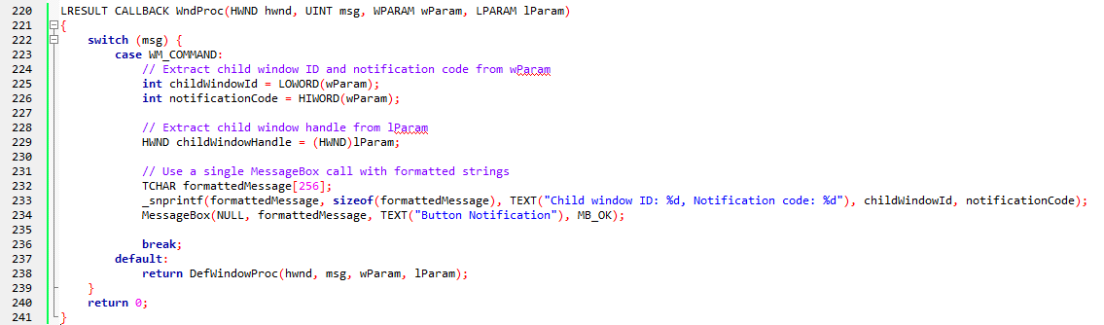

Zoom to see the code. It was long, I had to put it that way.

This corrected code:

* Uses a single MessageBox call with formatted strings to display both the child window ID and notification code in a single message box. This improves readability and user experience.
* Replaces the MessageBox calls with a single call to avoid halting the program flow multiple times. This maintains the responsiveness of the program.
* Uses _snprintf to format the message string into a buffer before passing it to MessageBox. This ensures that the formatted message fits within the buffer size.
* Uses TEXT macros for string literals to ensure compatibility with Unicode.

HOW PARENT WINDOW TALKS TO ITS CHILD WINDOW IN BTNLOOK:

Sending Messages to Child Windows

A window procedure can also send messages to its child windows. These messages can be used to get and set the state of child windows, change the style of child windows, and perform other tasks.

Button-Specific Messages

In addition to the standard window messages, there are also eight button-specific messages that are defined in WINUSER.H. These messages begin with the letters BM, which stand for "button message." The following table shows the button-specific messages:

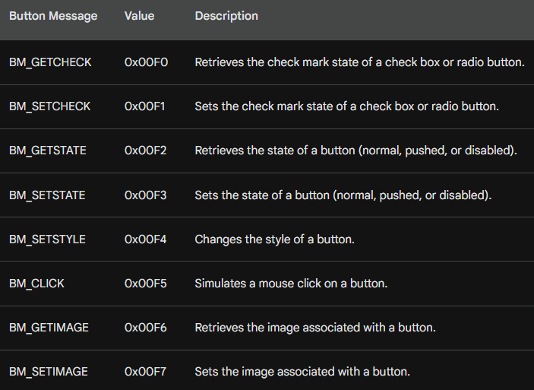

Getting and Setting the Check Mark of Check Boxes and Radio Buttons

The BM_GETCHECK and BM_SETCHECK messages are used to get and set the check mark of check boxes and radio buttons. To get the check mark of a check box or radio button, you would send the BM_GETCHECK message to the child window. To set the check mark of a check box or radio button, you would send the BM_SETCHECK message to the child window.

Getting and Setting the State of a Button

The BM_GETSTATE and BM_SETSTATE messages are used to get and set the state of a button. The state of a button can be normal, pushed, or disabled. To get the state of a button, you would send the BM_GETSTATE message to the child window. To set the state of a button, you would send the BM_SETSTATE message to the child window.

Changing the Style of a Button

The BM_SETSTYLE message is used to change the style of a button. The style of a button determines its appearance and behavior. To change the style of a button, you would send the BM_SETSTATE message to the child window.

Simulating a Mouse Click on a Button

The BM_CLICK message is used to simulate a mouse click on a button. This can be useful if you want to programmatically activate a button. To simulate a mouse click on a button, you would send the BM_CLICK message to the child window.

Retrieving and Setting the Image Associated with a Button

The BM_GETIMAGE and BM_SETIMAGE messages are used to retrieve and set the image associated with a button. This can be useful if you want to change the appearance of a button. To retrieve the image associated with a button, you would send the BM_GETIMAGE message to the child window. To set the image associated with a button, you would send the BM_SETIMAGE message to the child window.

Getting the Child Window ID

Each child window has a unique ID that can be obtained using the GetWindowLong function or the GetDlgCtrlID function.

Getting the Child Window Handle

Knowing the child window ID and the parent window handle, you can get the child window handle using the GetDlgItem function.

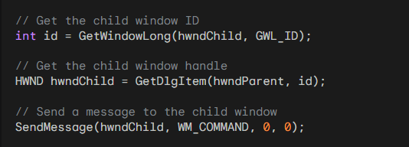

This code will get the child window ID, get the child window handle, and then send a WM_COMMAND message to the child window.

PUSH BUTTON DEFINITION AND APPEARANCE

Push buttons are rectangular controls that display text specified in the window text parameter of the CreateWindow function. The rectangle occupies the full height and width of the dimensions specified in the CreateWindow or MoveWindow function. The text is centered within the rectangle.

Push buttons are primarily used to trigger an immediate action without maintaining any type of on/off indication. They are commonly used in dialog boxes to initiate actions such as accepting or canceling a request.

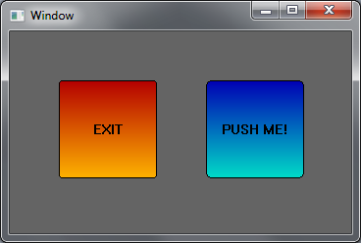

Types of Push Buttons

There are two types of push buttons: BS_PUSHBUTTON and BS_DEFPUSHBUTTON. The DEF in BS_DEFPUSHBUTTON stands for "default." When used in dialog boxes, the two types of push buttons function differently.

However, when used as child window controls, they function the same way. The only noticeable difference is that BS_DEFPUSHBUTTON has a heavier outline.

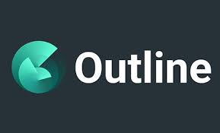

Visual Appearance

A push button looks best when its height is 7/4 times the height of a text character. BTNLOOK uses this ratio to ensure optimal appearance. The width of the push button must accommodate at least the width of the text, plus two additional characters.



Mouse Interactions

When the mouse cursor is within the push button and the mouse button is pressed, the button repaints itself using 3D-style shading to appear as if it is depressed.

Releasing the mouse button restores the original appearance and sends a WM_COMMAND message to the parent window with the notification code BN_CLICKED.



Keyboard Interactions

When a push button has the input focus, a dashed line surrounds the text. Pressing and releasing the Spacebar has the same effect as pressing and releasing the mouse button.

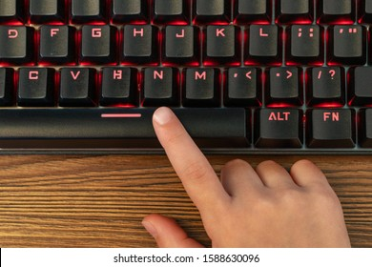

Simulating Push Button States

You can simulate a push-button flash by sending the window a BM_SETSTATE message. This causes the button to appear depressed:



To restore the button to its normal state, use the following SendMessage call:



In both cases, hwndButton is the window handle returned by the CreateWindow call.

Retrieving Push Button State

You can send a BM_GETSTATE message to a push button to retrieve its current state. The child window control returns TRUE if the button is depressed and FALSE if it is not depressed. However, most applications do not require this information.

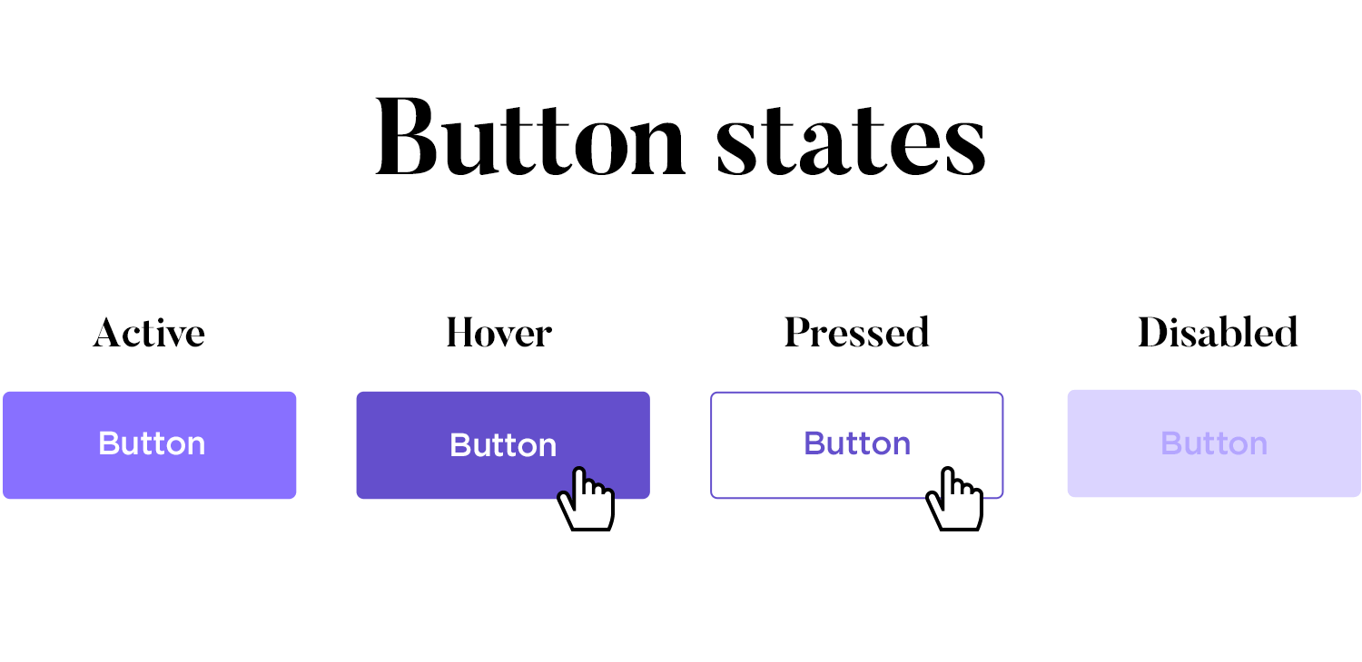

Additional Notes

* Push buttons do not retain any on/off information, so the BM_SETCHECK and BM_GETCHECK messages are not used.
* Push buttons are typically used in conjunction with event handlers to perform actions when clicked.

CHECK BOX DEFINITION AND APPEARANCE

A check box is a square box with text typically appearing to the right of it. Check boxes are commonly used in applications to allow users to select options. They function as toggle switches: clicking the box once causes a check mark to appear; clicking again toggles the check mark off.

Types of Check Boxes

There are two main types of check boxes:

* BS_CHECKBOX: This style requires the programmer to control the check mark state using BM_SETCHECK and BM_GETCHECK messages.
* BS_AUTOCHECKBOX: This style automatically toggles the check mark state when clicked and doesn't require any manual intervention.

BS_CHECKBOX Handling

To manage the check mark state of a BS_CHECKBOX check box, you can use the following code:



This code retrieves the current check state using BM_GETCHECK and then toggles the state using BM_SETCHECK.

BS_AUTOCHECKBOX Handling

For BS_AUTOCHECKBOX check boxes, you can simply ignore WM_COMMAND messages and use BM_GETCHECK to retrieve the check state:



Additional Check Box Styles

BS_3STATE: This style allows a third state, indicated by a grayed-out check mark, which occurs when you send WM_SETCHECK with wParam equal to 2. This state indicates an indeterminate or irrelevant selection.

BS_AUTO3STATE: This style automatically toggles the check mark state between the three states (unchecked, checked, indeterminate) when clicked.

Check Box Alignment and Dimensions

The check box is aligned with the rectangle's left edge and centered within the top and bottom dimensions specified during the CreateWindow call. The minimum height for a check box is one character height, and the minimum width is the number of characters in the text, plus two.

User Interaction and Messages

Clicking anywhere within the check box rectangle sends a WM_COMMAND message to the parent window. The parent window can use this message to handle the check box selection and update its state accordingly.

RADIO BUTTONS

Radio buttons are a type of control that allows users to select one of a group of mutually exclusive options. They are commonly used in dialog boxes to present a set of choices, where only one choice can be selected at a time.

Radio buttons resemble check boxes, but instead of a square box, they have a small circle. A filled circle indicates that the radio button is selected.

Radio buttons typically have the window style BS_RADIOBUTTON or BS_AUTORADIOBUTTON. The latter style is specifically designed for use in dialog boxes.

Radio Button Behavior

Unlike check boxes, radio buttons do not function as toggles. Clicking a selected radio button does not deselect it. Instead, selecting one radio button automatically deselects any other radio buttons in the same group.

Radio Button State Management

When you receive a WM_COMMAND message from a radio button, you should update the state of all radio buttons in the same group.

To select the radio button that sent the WM_COMMAND message, send it a BM_SETCHECK message with wParam equal to 1:



To deselect all other radio buttons in the same group, send them BM_SETCHECK messages with wParam equal to 0:

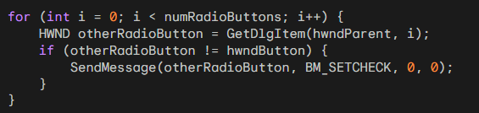

GROUP BOXES

Group boxes, which have the BS_GROUPBOX style, are non-interactive controls that serve to visually group related control elements. They are commonly used to enclose other button controls, such as radio buttons or check boxes, to provide a clear visual distinction between different groups of options.

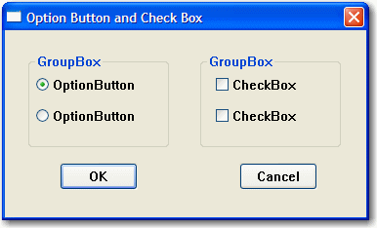

Group Box Appearance

Group boxes consist of a rectangular outline with their window text displayed at the top. They do not have any associated check mark or other visual indication of their state.

Group Box Function

Group boxes do not process mouse or keyboard input, nor do they send WM_COMMAND messages to their parent window. Their primary purpose is to organize and group related controls to enhance the user interface's clarity and usability.

CHANGING BUTTON TEXT

To change the text displayed on a button, you can use the SetWindowText function. This function takes two arguments:

* hwnd: The handle to the button window you want to modify.
* pszString: A pointer to a null-terminated string containing the new text for the button.

Here's an example of how to change the text of a button:



Obtaining Button Text

You can retrieve the current text displayed on a button using the GetWindowText function. This function takes three arguments:

* hwnd: The handle to the button window you want to get the text from.
* pszBuffer: A pointer to the buffer where the retrieved text will be stored.
* iMaxLength: The maximum number of characters to copy into the buffer.

The function returns the length of the copied string, or zero if an error occurred.

Here's an example of how to get the current text of a button:

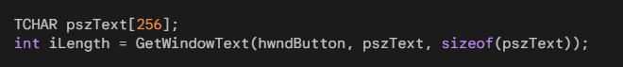

Visible and Enabled Buttons

For a button to respond to mouse and keyboard input, it must be both visible and enabled. When a button is visible but not enabled, its text is displayed in gray.

Making a Button Visible

To make a button visible, you can include the WS_VISIBLE style in the window class when creating the button. Alternatively, you can call the ShowWindow function with the SW_SHOWNORMAL flag after creating the button.

*Here's an example of making a button visible using the window class style:*



Here's an example of making a button visible using ShowWindow:



Hiding a Button

To hide a button, you can call the ShowWindow function with the SW_HIDE flag.

Here's an example of hiding a button:



Enabling and Disabling Buttons

By default, a button is enabled. To disable a button, you can call the EnableWindow function with the FALSE flag. When a button is disabled, its text appears in gray, and it does not respond to mouse or keyboard input.

Here's an example of disabling a button:



Enabling a Button

To enable a disabled button, you can call the EnableWindow function with the TRUE flag.

Here's an example of enabling a disabled button:



Checking Button Visibility and Enabled State

You can determine whether a button is visible using the IsWindowVisible function. This function takes one argument:

* hwnd: The handle to the button window you want to check.

The function returns TRUE if the button is visible and FALSE if it is hidden.

Here's an example of checking whether a button is visible:



You can determine whether a button is enabled using the IsWindowEnabled function. This function takes one argument:

* hwnd: The handle to the button window you want to check.

The function returns TRUE if the button is enabled and FALSE if it is disabled.

Here's an example of checking whether a button is enabled:



INPUT FOCUS AND BUTTONS

*How buttons interact with input focus and how to prevent them from stealing focus from the parent window:*

When a push button, check box, radio button, or owner-draw button is clicked with the mouse, it gains input focus. This is indicated by a dashed line that surrounds the text of the control.

When a child window control gains input focus, it receives all keyboard input instead of the parent window. However, most button controls only respond to the Spacebar, which acts as a simulated mouse click.

Preventing Buttons from Stealing Focus

To prevent a button from taking input focus away from the parent window, you can process WM_KILLFOCUS messages in the parent window's message handling function.

When a WM_KILLFOCUS message is received, it indicates that the parent window is about to lose input focus.

You can check if the window losing focus is one of the child window controls by comparing it to the handles stored in an array. If it is, you can call SetFocus to restore the input focus to the parent window.

Code Example 1

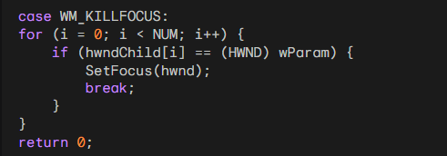

In this code, the parent window checks each child window handle in the array and restores focus to itself if the losing focus window matches one of the child window handles.

Alternative Code Example:

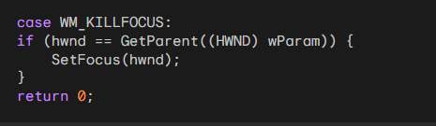

This alternative approach directly compares the parent window handle to the window losing focus. It is simpler but less obvious than the first method.

Limitations of Preventing Focus Stealing

Both of these methods have a drawback: they prevent the button from responding to the Spacebar keypress. This is because the button never gains input focus. A better solution would allow the button to receive input focus while also enabling tab navigation between buttons.

Window Subclassing for Improved Focus Handling

A technique called "window subclassing" can be used to achieve this. Subclassing allows you to intercept and modify the behavior of an existing window procedure. By subclassing the button window procedure, you can capture keyboard events, including the Tab key, and handle them appropriately.

Window Subclassing Implementation

The COLORS1 program in the later part of the chapter demonstrates how to implement window subclassing to handle button focus and tab navigation. It involves creating a subclass procedure that overrides the default button procedure and handles keyboard events accordingly.

Buttons can interfere with keyboard input by stealing focus from the parent window. Techniques like WM_KILLFOCUS processing and window subclassing can be employed to prevent this and maintain control over keyboard input while still allowing buttons to function as expected.

We've come this far but i want you to explain to me like a teenager, what is input focus, with illustrations, and what is a handle?

Input Focus

Imagine you're sitting at a computer with multiple open programs, each with its own window. When you click on a particular window, it becomes the active window, and that's where your keyboard input goes. That's what input focus is – it's the ability of a window to receive keyboard input.



Think of it like a spotlight. When you shine the spotlight on a particular window, that window is in focus, and it's like you're talking directly to that window. Other windows might be open, but they're not paying attention to your keyboard input.

Illustration

Let's say you have a web browser window open, and you're typing a search query. The web browser window has the input focus, so all your keystrokes go towards entering the search term.

 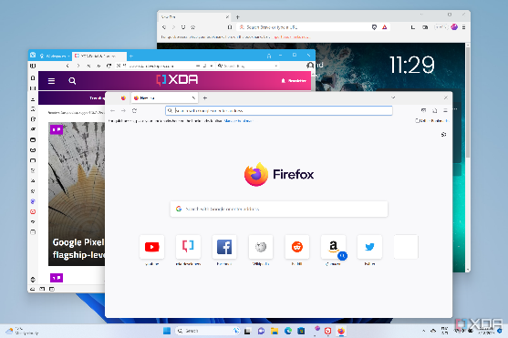

If you switch to a different window, like a calculator app, and start pressing buttons, the calculator app gets the input focus, and your keystrokes now control the calculator instead.

 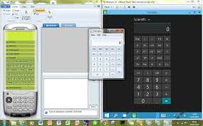

Window Handles

Every window has a unique identifier called a window handle. It's like a special address that lets your computer identify and keep track of all the different windows you have open.

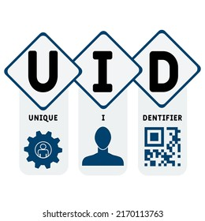

Think of it like a house address. Each house has a unique address that allows the postman to deliver mail to the right place. Similarly, window handles allow your computer to send messages to the correct windows.

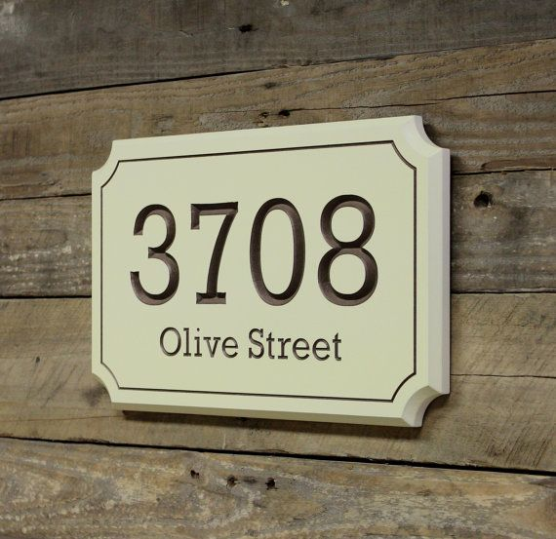

Relationship between Input Focus and Window Handles

The window handle is the behind-the-scenes mechanism that allows input focus to be assigned to specific windows. When you click on a window, your computer uses the window handle to identify that window and give it the input focus.

So, input focus is like the spotlight that highlights the currently active window, and window handles are like the unique addresses that let your computer identify and control those windows.

System Colors in Windows

System colors are a set of predefined colors that Windows uses to paint various elements of the graphical user interface (GUI), such as window borders, titles, buttons, and text. These colors are stored by the system and can be accessed using the GetSysColor and SetSysColors functions.

Table of System Colors

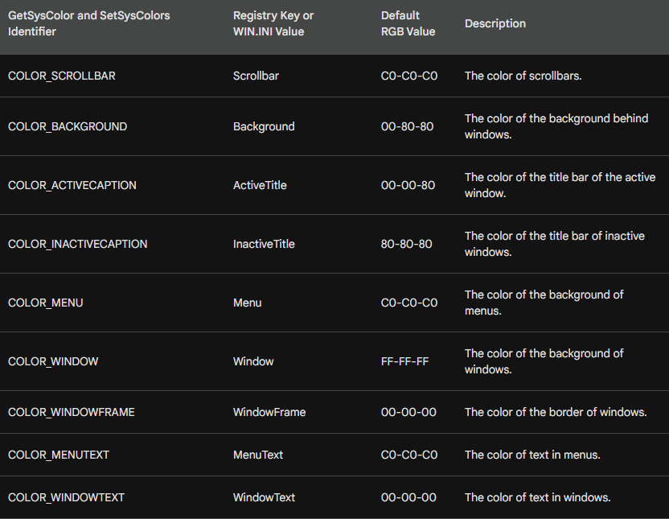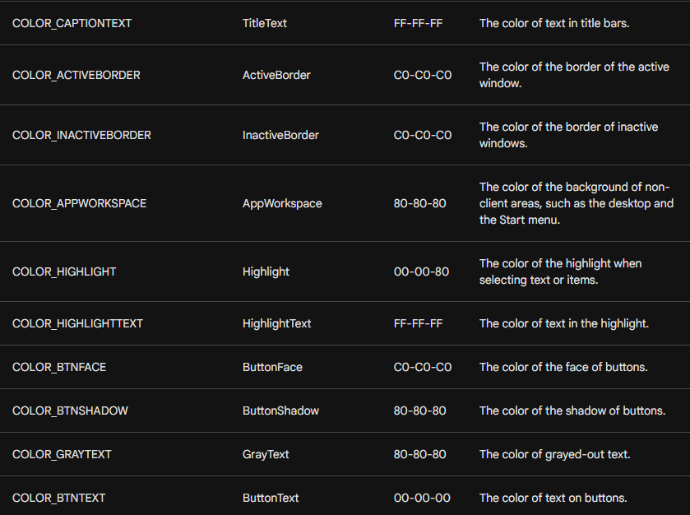

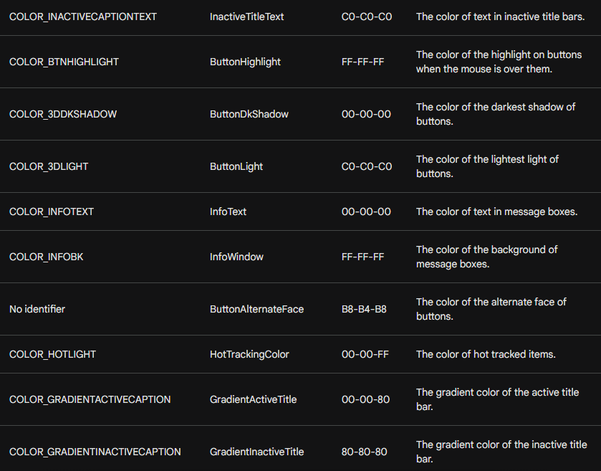

The default RGB values for these colors can vary slightly depending on the display driver.

CHALLENGES WITH SYSTEM COLORS FOR BUTTONS

In recent versions of Windows, the use of system colors for buttons has become increasingly complex due to the growing visual complexity of controls and the introduction of three-dimensional appearances. This poses several challenges for programmers:

Inconsistent Color Usage: While some system colors have intuitive names that match their intended purpose, others have become less consistent, making it difficult to predict the exact color behavior.



Multiple Colors per Button: Each button requires multiple system colors for its various elements, such as the face, shadow, text, and border. This increases the complexity of managing button colors.

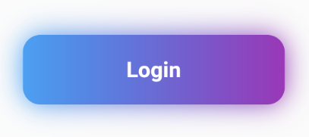

Color Clash with Client Area: If the client area background color is set to the default white, it clashes with the system colors used for buttons, creating an inconsistent visual appearance.

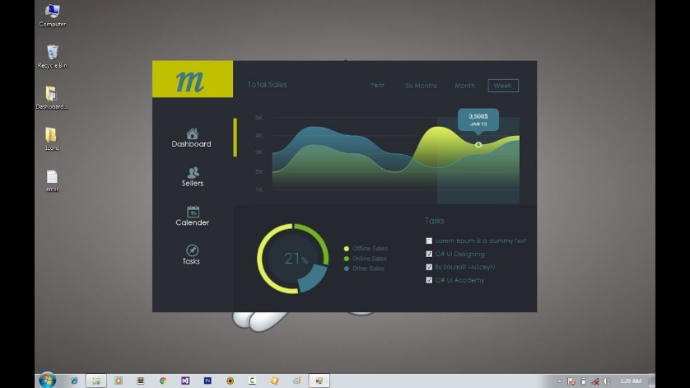

Solutions to Address Color Issues

To address these challenges, programmers can employ several strategies:

Yield to System Colors: By setting the client area background color to COLOR_BTNFACE, the client area matches the default button face color, eliminating the color clash.

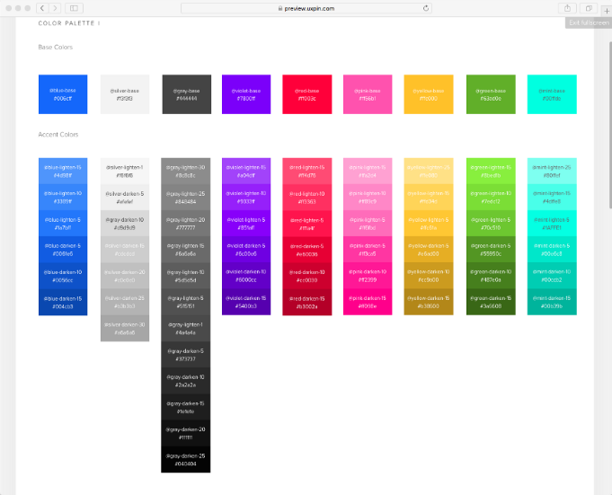

Explicitly Set Text Colors: Since the default text colors in the device context are white (background) and black (text), programmers need to explicitly set the text background color to COLOR_BTNFACE and the text color to COLOR_WINDOWTEXT to match the button colors.

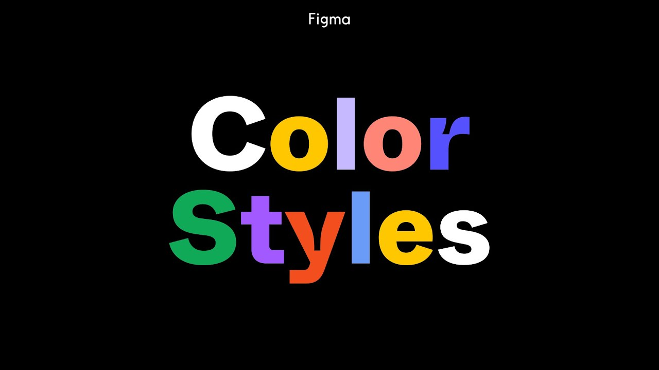

Handle System Color Changes: If the user changes system colors while the program is running, the client area needs to be invalidated to reflect the new colors. This can be done using the WM_SYSCOLORCHANGE message.

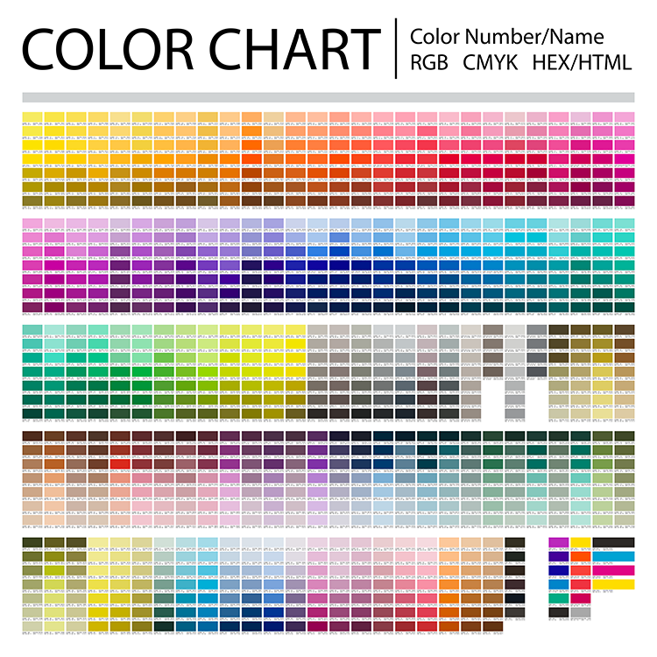

Alternative Approach: Custom Colors

An alternative approach is to avoid using system colors altogether and define custom colors for the client area, buttons, and text.

This provides more control over the visual appearance and eliminates the need to handle system color changes. However, this approach requires managing multiple custom colors and ensuring consistency across the application.

Code examples:



This code sets the background color of the client area to COLOR_BTNFACE, which is the system color used for dialog boxes and message boxes. This helps to avoid color clash with the buttons.



This code sets the text background color and text color to the system colors COLOR_BTNFACE and COLOR_WINDOWTEXT, respectively. This ensures that the text is consistent with the button colors.

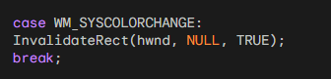

This code handles the WM_SYSCOLORCHANGE message, which is sent when the system colors change. The code invalidates the client area, which causes Windows to redraw it using the new system colors.

Here's an explanation of the code:

* wndclass.hbrBackground = (HBRUSH) (COLOR_BTNFACE + 1);: This line sets the background color of the client area to COLOR_BTNFACE, which is a system color defined by Windows. The + 1 is necessary because Windows expects the value of hbrBackground to be one more than the system color identifier.
* SetBkColor(hdc, GetSysColor(COLOR_BTNFACE));: This line sets the background color of the current device context to COLOR_BTNFACE. The device context is used for drawing text and graphics.
* SetTextColor(hdc, GetSysColor(COLOR_WINDOWTEXT));: This line sets the text color of the current device context to COLOR_WINDOWTEXT. This is the system color used for window text.
* case WM_SYSCOLORCHANGE: InvalidateRect(hwnd, NULL, TRUE); break;: This code handles the WM_SYSCOLORCHANGE message, which is sent when the system colors change. The InvalidateRect function causes Windows to redraw the client area of the window.
* The NULL parameter specifies that the entire client area should be redrawn. The TRUE parameter tells Windows to send a WM_PAINT message to the window when the redrawing is complete. This message is necessary to trigger the window's paint handling function, which will redraw the window with the new system colors.

WM_CTLCOLORBTN Message

The WM_CTLCOLORBTN message is sent to the parent window of a button control before the button is about to paint its client area. This gives the parent window the opportunity to customize the colors used to paint the button.

Message Parameters

* wParam: The handle to the button's device context.
* lParam: The button's window handle.

Processing WM_CTLCOLORBTN

When the parent window procedure receives a WM_CTLCOLORBTN message, it can perform the following actions:

* Set Text Color: Use SetTextColor to set the text color of the button.
* Set Text Background Color: Use SetBkColor to set the text background color of the button.
* Return Brush Handle: Return a handle to a brush that will be used to paint the button's background.

Limitations of WM_CTLCOLORBTN

* Limited Scope: Only push buttons and owner-drawn buttons send WM_CTLCOLORBTN to their parent windows.
* Ineffective for Owner-Drawn Buttons: Owner-drawn buttons are already responsible for drawing their own backgrounds, so processing WM_CTLCOLORBTN for them is redundant.

Alternative Approaches

* SetSysColors: Use SetSysColors to change the system colors for buttons. However, this affects all buttons in the system, which may not be desirable.
* Custom Controls: Create custom controls that handle their own drawing and color management.

While WM_CTLCOLORBTN offers a mechanism for customizing button colors, its limitations make it less useful for practical applications. Alternative approaches, such as using SetSysColors or creating custom controls, may be more suitable for achieving specific color customizations.



Owner-Draw Buttons

The OWNDRAW program demonstrates the use of owner-draw buttons, which provide complete control over the visual appearance of buttons.

The program consists of two main parts: the WinMain function and the WndProc window procedure.

The WinMain function performs the following tasks:

* Register the Window Class: Registers the window class that defines the appearance and behavior of the window.
* Create the Main Window: Creates the main window of the application using the registered window class.
* Show the Window: Displays the main window on the screen.
* Enter the Message Loop: Enters the message loop, which processes messages sent to the window until the window is closed.

WndProc Window Procedure

The WndProc window procedure handles messages sent to the window. The program handles the following messages:

* WM_CREATE: Initializes the window by creating two owner-draw buttons.
* WM_SIZE: Resizes the buttons when the window size changes.
* WM_COMMAND: Handles button clicks by resizing the window.
* WM_DRAWITEM: Draws the owner-draw buttons.

Drawing Owner-Draw Buttons

The WM_DRAWITEM message handler is responsible for drawing the owner-draw buttons. It uses the Triangle function to draw triangles on the buttons and the InvertRect and DrawFocusRect functions to handle button selection and focus.

Button Functionality

The button on the left decreases the window size by 10% when clicked, while the button on the right increases the window size by 10%. This is achieved by modifying the window's rectangle and calling the MoveWindow function to update the window's position and size.

The OWNDRAW program demonstrates the use of owner-draw buttons to create custom button appearances. Owner-draw buttons provide flexibility in designing buttons but require more programming effort compared to standard buttons.

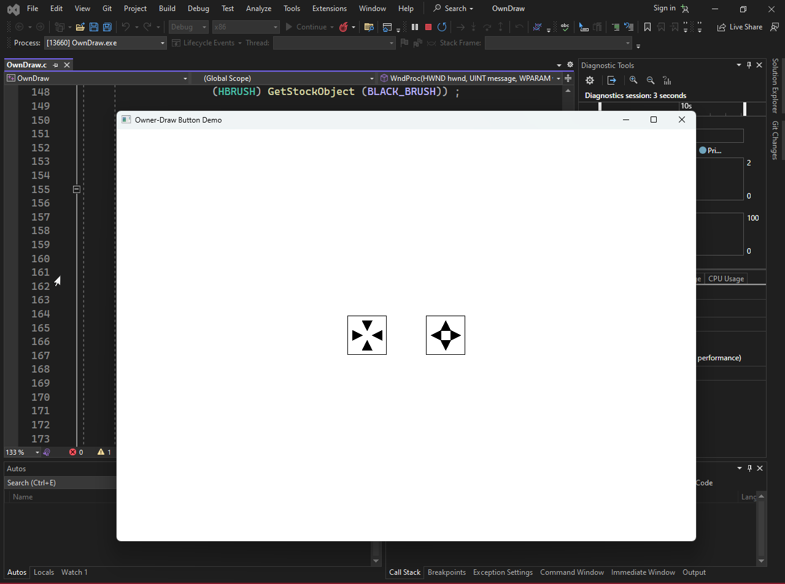

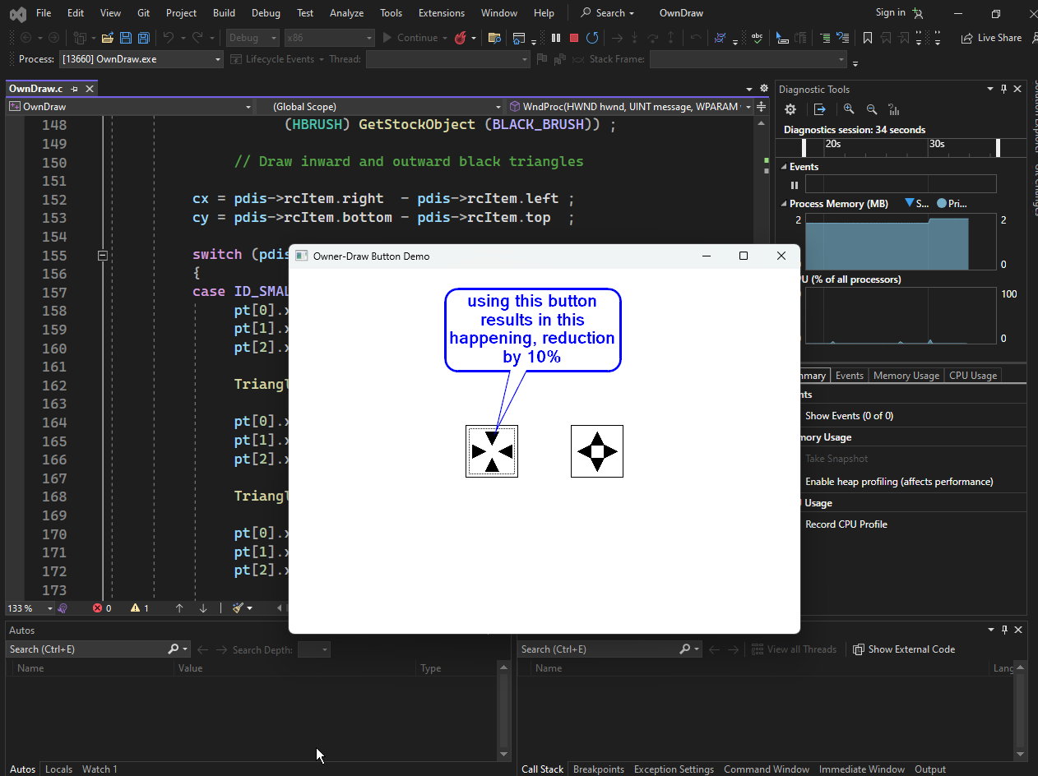

And vice versa…